**Wake County Public School System**

**Practice Algebra I/Integrated I EOC Spring 2013**

**Common Core Math I**

**Student Booklet**



**High School Programs**

**Academics Division**



**High School Programs**

**Academics Division**

**Calculator Inactive**

1. Which data table represents univariate data?

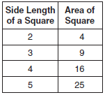A

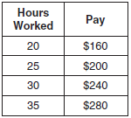B

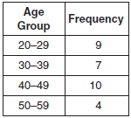C

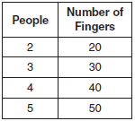D

1. A scatter plot was constructed on the graph below and a line of best fit was drawn.

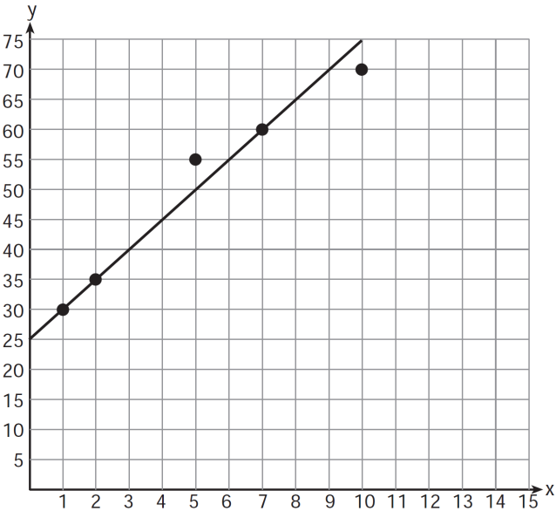

What is the equation of this line of best fit?

* + 1. 
    2. 
    3. 
    4. 

1. A librarian recorded the number of books that 10 students checked out during lunch on Monday. The table below shows the number of books checked out by each student.

|  |  |
| --- | --- |
| Student | Number of Books |
| John | 3 |
| Larry | 4 |
| Tyrone | 5 |
| Sheila | 2 |
| Parker | 2 |
| Louisa | 4 |
| Juanita | 3 |
| Rosalie | 3 |
| Carmen | 2 |
| Joseph | 2 |

Carlos checks out 8 books on Tuesday. Which is true if Carlos’ number is included in the data set?

* + 1. The median increases.
    2. The standard deviation decreases.
    3. The mean increases.
    4. The interquartile range increases.

1. The box-and-whisker plot below represents the ages of 12 people. What percentage of these people are ages 15 or older?

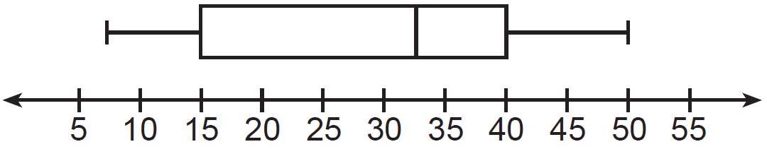

* + 1. 25
    2. 35
    3. 75
    4. 85

1. A student graphed the parabola shown below.

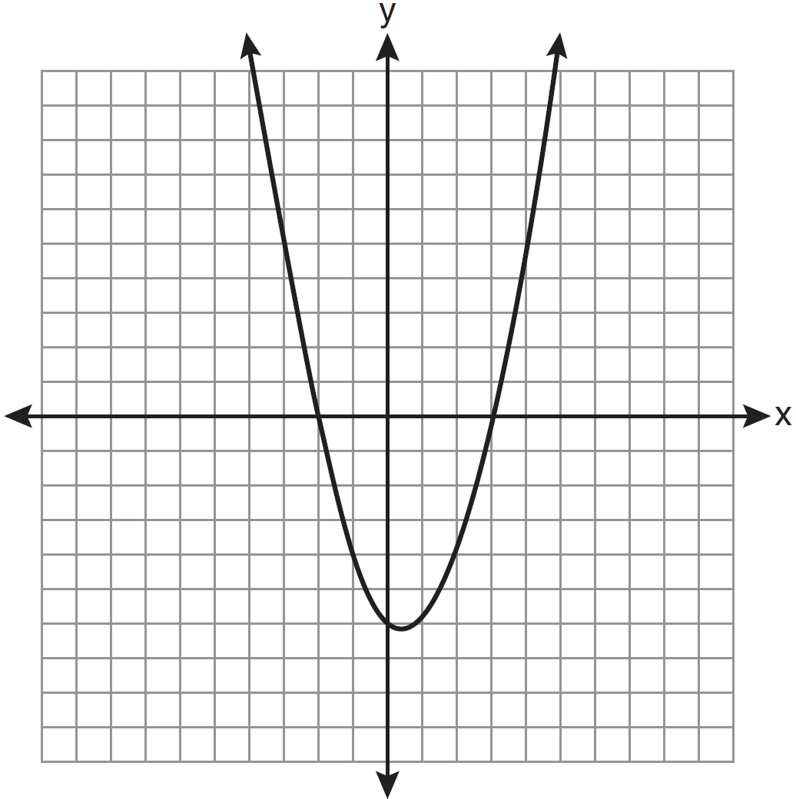

Which quadratic equation corresponds to this graph? Note: $a$ is a constant; $a≠0.$

$y=a(x-2)(x+3)$

$y=a(x+2)(x+3)$

$y=a(x-2)(x-3)$

$y=a(x+2)(x-3)$

1. Which graph represents the solution of $3y-9≤6x$?

|  |  |  |  |
| --- | --- | --- | --- |
| A |  | B |  |
| C |  | D |  |

**Gridded Response**

**Questions 7 through 18 require you to write your answers in the boxes provided on your answer sheet. Write only one number or symbol in each box and fill in the circle in each column that matches what you have printed. Fill in only one circle in each column.**

1. Josh and Mae work at a concession stand. They each earn $8 per hour. Josh worked three hours more than Mae. If Josh and Mae earned a total of $120, how many hours did Josh work?
2. Roberta needs ribbon for a craft project. The ribbon sells for $3.75 per yard. Find the cost, in dollars, for 48 inches of the ribbon. (1 yard = 36 inches)
3. Peter begins his kindergarten year able to spell 10 words. He is going to learn to spell 2 new words every day. Write an inequality that can be used to determine how many days, *d*, it takes Peter to be able to spell *at least* 75 words. Use this inequality to determine the minimum number of whole days it will take for him to be able to spell *at least* 75 words.
4. Byron is 3 years older than Doug. The product of their ages is 40. How old is Doug?
5. A contractor needs 54 square feet of brick to construct a rectangular walkway. The length of the walkway is 15 feet more than the width. Write an equation that could be used to determine the dimensions of the walkway. Solve this equation to find the length, in feet, of the walkway.
6. A turtle and a rabbit are in a race to see who is first to reach a point 100 feet away. The turtle travels at a constant speed of 20 feet per minute for the entire 100 feet. The rabbit travels at a constant speed of 40 feet per minute for the first 50 feet, stops for 3 minutes, and then continues at a constant speed of 40 feet per minute for the last 50 feet. Determine which animal won the race and by how much time. Grid in how much time, in seconds.
7. The sum of three consecutive odd integers is 18 less than five times the middle number. Find the three integers. Grid in the largest of the three integers.
8. A line segment has endpoints A(5, -3) and B(-6, 2). The point K is the midpoint of segment AB. What is the slope of a line perpendicular to segment AB and passing through K? Express your answer as a fraction in lowest terms.
9. Simplify. Write your answer as a fraction in lowest terms.
$$6^{-2}∙8^{\frac{1}{3}}$$

10. Dennis compared the *y*-intercept of the graph of $f\left(x\right)=3x+5$ to the *y*-intercept of the function $g\left(x\right)$ represented in the table below.

|  |  |
| --- | --- |
| $$x$$ | $$g(x)$$ |
| -4 | 4 |
| -3 | 0 |
| -2 | -4 |
| -1 | -8 |
| 0 | -12 |
| 1 | -16 |

What is the difference when the *y*-intercept of $f\left(x\right)$ is subtracted from the *y*-intercept of $g\left(x\right)$?

1. Six organisms are present in a sample now, if these organisms double every thirty minutes, how many will be present after 90 minutes (assuming none of them die)?
2. Jack bought 3 slices of cheese pizza and 4 slices of mushroom pizza for a total cost of $12.50. Grace bought 3 slices of cheese pizza and 2 slices of mushroom pizza for a total cost of $8.50. What is the cost in dollars of one slice of cheese pizza?

**This is the end of the calculator inactive test questions.**

**Directions:**

**1. Look back over your answers for the calculator inactive questions. You will not be able to go back and work on these questions once you are given a calculator.**

**2. Raise your hand to let your teacher know you are ready to begin the calculator active test questions.**

**3. Do not begin work on the calculator active test questions until your teacher has given you a calculator.**





**Calculator Active**

1. Which data set describes a situation that could be classified as quantitative?
   * 1. the phone numbers in a telephone book
     2. the addresses for students at Hopkins High School
     3. the zip codes of residents in the city of Buffalo, New York
     4. the time it takes each of Mr. Harper’s students to complete a test
2. Which set of data would you expect to have the greatest standard deviation?
   * 1. The heights in cm of all of the students in the first-grade classes in a large elementary school
     2. The heights in cm of all of the first-grade teachers in the elementary school
     3. The heights in cm of all of the first-grade students and all of the first-grade teachers in the elementary school
     4. The circumferences in cm of the wrists for all the students in your class
3. What is half of ?
   * 1. **
     2. **
     3. 
     4. **
4. Grant has $58 in a savings account. He plans on depositing $30 into the account each month and not taking any money out of the account. Which function rule will give the total amount he has in the account $T$ after any number of months $n$?
$T = 58n + 30$

$T = 30 + n + 58$

$T = 30n + 58$

$T = 30(58 + n)$

5. If $\frac{ey}{n}+k=t$, what is *y* in terms of *e*, *n*, *k*, and *t*?
$y=\frac{tn+k}{e}$

$y=\frac{tn-k}{e}$

$y=\frac{n(t+k)}{e}$

$y=\frac{n(t-k)}{e}$

6. Timmy bought a skateboard and two helmets for a total of *d* dollars. If each helmet cost *h* dollars, the cost of the skateboard could be represented by
   * 1. 
     2. 
     3. 
     4. 
7. Tim ate four more cookies than Alice. Bob ate twice as many cookies as Tim. If x represents the number of cookies Alice ate, which expression represents the number of cookies Bob ate?
   * 1. 2 + (*x* + 4)
     2. 2*x* + 4
     3. 2(*x* + 4)
     4. 4(*x* + 2)
8. Which statement is true about the relation shown on the graph below?

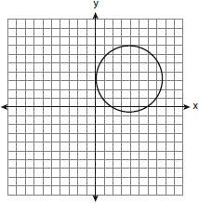

* + 1. It is a function because there exists one *x*-coordinate for each *y*-coordinate.
    2. It is *not* a function because there are multiple *y*-values for a given *x*-value.
    3. It is a function because there exists one *y*-coordinate for each *x*-coordinate.
    4. It is *not* a function because there are multiple *x*-values for a given *y*-value.

1. Which equation represents a line that is parallel to the line **?
   * 1. **
     2. **
     3. **
     4. 
2. Mr. Smith invested $2,500 in a savings account that earns 3% interest compounded annually. He made no additional deposits or withdrawals. Which expression can be used to determine the number of dollars in this account at the end of 4 years?
   * 1. 
     2. 
     3. 
     4. 
3. A new car was purchased for $35,000.00. Once it leaves the lot, it depreciates at a steady rate of 9% per year. What is the value of the car in 10 years?
   * 1. $13,629.56
     2. $82,857.73
     3. $21,370.44
     4. $48,629.56
4. Campsite *A* and campsite *B* are located directly opposite each other on the shores of Lake Omega, as shown in the diagram below. The two campsites form a right triangle with Sam’s position, *S*. The distance from campsite *B* to Sam’s position is 1,300 yards, and campsite *A* is 1,700 yards from his position.

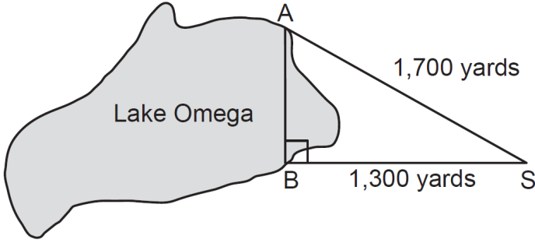

What is the distance from campsite *A* to campsite *B*, to the *nearest yard*?

* + 1. 1,095
    2. 1,096
    3. 2,140
    4. 2,141

1. What is the equation of the line that passes through the points $\left(-3, 8\right)$ and $\left(1, 4\right)$?
$y=-x-8$

$y=-x+5$

$y=x+5$

$y=\frac{11}{3}x+19$

2. The table below represents the linear relationship between the number of toppings for a medium sized pizza, $x$, and the price paid, $y$.

|  |  |
| --- | --- |
| $$x$$ | $$y$$ |
| 0 | $10.00 |
| 1 | $12.50 |
| 2 | $15.00 |
| 3 | $17.50 |
| 4 | $20.00 |

What does the slope mean in this context?

* + 1. For every topping added the price increases by $1.25.
    2. For every topping added, the price decreases by $1.25.
    3. For every topping added, the price increases by $2.50.
    4. For every topping added, the price decreases by $2.50.

1. A local shipping company charges $4.95 for the first pound and $1.25 for each additional pound the package weighs. What equation would represent the relationship between the cost of mailing the package, $c$, and the total weight of the package, $w$, in pounds?
$c = 1.25w$

$c = 4.95+1.25w$

$c = 1.25\left(w-1\right)+4.95$

$c = 1.25+4.95(w-1)$

2. The table represents the relationship between calories, $C$, consumed and the number of cookies eaten $n$.

|  |  |
| --- | --- |
| $$n$$ | $$C$$ |
| 0 | 0 |
| 1 | 75 |
| 2 | 150 |
| 3 | 225 |
| 4 | 300 |
| 5 | 375 |

What does the y-intercept mean in the context of this problem?

* + 1. When 0 cookies are eaten, 0 calories are consumed.
    2. When 1 cookie is eaten, 75 calories are consumed.
    3. When 75 cookies are eaten, 1 calorie is consumed.
    4. When 0 cookies are eaten, 75 calories are consumed.

1. Given *f(x) = 2x + 4* and the graph of *g(x)* below, which of the following statements is correct?

* + 1. The graph of *f(x)* is steeper than the graph of *g(x).*
    2. The graph of *g(x)* is steeper than the graph of *f(x).*
    3. The graphs of *f(x)* and *g(x)* have the same slope.
    4. The graphs of *f(x)* and *g(x)* are perpendicular.

1. Each year the local country club sponsors a tennis tournament.  Play starts with 128 participants.  During each round, half of the players are eliminated.  How many players remain after 5 rounds?
   * 1. 64
     2. 16
     3. 8
     4. 4
2. Given the parent function $y=2^{x}$, describe how $y=2^{(x+4)}+3$ is shifted.
   * 1. Shifted up 4 and right 3
     2. Shifted right 4 and up 3
     3. Shifted left 4 and up 3
     4. Shifted left 4 and down 3
3. The graph depicts the growth of 3 different plants. Which plant had the highest growth rate? Which plant had the highest initial height?



* + 1. plant 2; plant 1
    2. plant 2; plant 3
    3. plant 3; plant 2
    4. plant 1; plant 2

1. Find the area of the shaded region. Simplify.









* + 1. 
    2. 
    3. 
    4. 

1. Carmen wins the lottery and is given 2 options to receive her winnings, as shown below. In both equations, $W$ is the amount of winnings she receives for a certain year, and $t$ represents time, in years. For either option, Carmen will receive money for a total of 5 years, with *t* = 1 for the 1st year, *t* = 2 for the 2nd year, and so on.

Option 1: $W=20,000+150t$ Option 2: $w= {10}^{t}$

Which option will result in a greater amount of total winnings and by how much more?

* + 1. Option 1; by $2,500
    2. Option 1; by $102,250
    3. Option 2; by $8,860
    4. Option 2; by $111,110

1. Gwen’s math teacher wrote the function $f\left(x\right)=2{\left(3\right)}^{x}$ on the board. The she wrote another function on the board, $g\left(x\right)= 2{(3)}^{x}+7$, and asked the students to graph the new function. How does the graph of $g(x)$ compare to the graph of ?
   * 1. The new graph moves right 7 units.
     2. The new graph moves left 7 units.
     3. The new graph moves down 7 units.
     4. The new graph moves up 7 units.
2. Mrs. Smith wrote "Eight less than three times a number is greater than fifteen" on the board. If *x* represents the number, which inequality is a correct translation of this statement?
   * 1. 
     2. 
     3. 
     4. 
3. Factored completely, the expression  is equivalent to
   * 1. 
     2. 
     3. 
     4. 
4. The gas tank in a car holds a total of 16 gallons of gas. The car travels 75 miles on 4 gallons of gas. If the gas tank is full at the beginning of a trip, which graph represents the rate of change in the amount of gas in the tank?

|  |  |  |  |
| --- | --- | --- | --- |
| A |  | B |  |
| C |  | D |  |

1. When  is subtracted from , the difference is
   * 1. 
     2. 
     3. 
     4. 
2. In a linear relationship, the independent variable increases at a constant rate while the dependent variable decreases at a constant rate. The slope of this line is
   * 1. zero
     2. positive
     3. negative
     4. undefined
3. Which equation most closely represents the line of best fit for the scatter plot below?

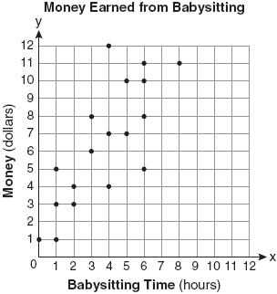

* + 1. 
    2. 
    3. 
    4. 

1. Which set of ordered pairs represents a function?
   * 1. 
     2. 
     3. 
     4. 
2. A hiker walked 12.8 miles from 9:00 a.m. to noon. He walked an additional 17.2 miles from 1:00 p.m. to 6:00 p.m. What is his average rate for the entire walk, in miles per hour?
   * 1. 3.75
     2. 3.86
     3. 4.27
     4. 7.71
3. The maximum height and speed of various roller coasters in North America are shown in the table below.

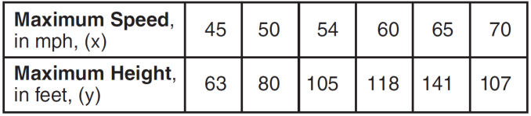

Which graph represents a correct scatter plot of the data?

|  |  |
| --- | --- |
| A |  |
| B |  |
| C |  |
| D |  |

1. Which ordered pair is a solution to the system of equations and **?
   * 1. 
     2. 
     3. 
     4. 
2. A study showed that a decrease in the cost of carrots led to an increase in the number of carrots sold. Which statement best describes this relationship?
   * 1. positive correlation and a causal relationship
     2. negative correlation and a causal relationship
     3. positive correlation and not a causal relationship
     4. negative correlation and not a causal relationship
3. A method for solving  is shown below. Identify the property used to obtain each of the two indicated steps.

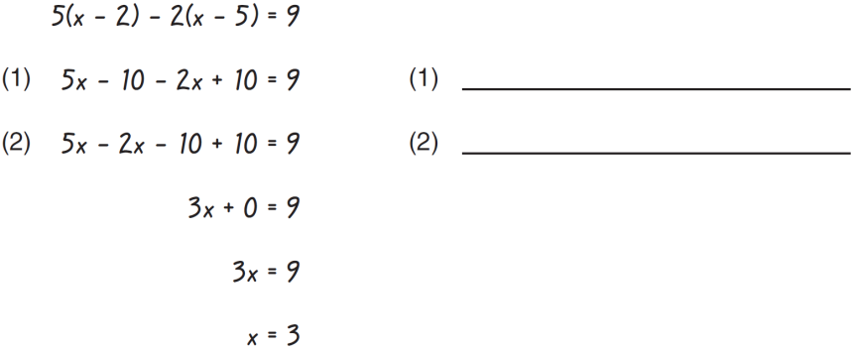

* + 1. Multiplication Property of Equality; Commutative Property
    2. Multiplication Property of Equality; Associative Property
    3. Distributive Property; Commutative Property
    4. Distributive Property; Associative Property

1. The function $h\left(x\right)=-10t^{2}+20t+80$ models the approximate height of an object $t$ seconds after it is launched. How many seconds does it take the object to hit the ground?
   * 1. -4
     2. -2
     3. 2
     4. 4
2. Which ordered pair is in the solution set of the system of linear inequalities graphed below?

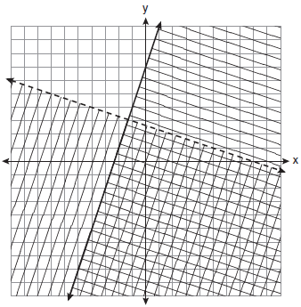

* + 1. 
    2. 
    3. 
    4. 

1. A cylindrical container has a diameter of 12 inches and a height of 15 inches, as illustrated in the diagram below.

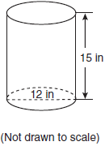

What is the volume of this container to the *nearest tenth* of a cubic inch?

* + 1. 6,785.8
    2. 4,241.2
    3. 2,160.0
    4. 1,696.5

1. An electronics store sells DVD players and cordless telephones. The store makes a $75 profit on the sale of each DVD player (*d*) and a $30 profit on the sale of each cordless telephone (*c*). The store wants to make a profit of at least $255.00 from its sales of DVD players and cordless phones. Which inequality describes this situation?
   * 1. 
     2. 
     3. 
     4. 
2. The graphs of the equations $y=2x-7$ and $2y-kx=14$ are parallel when *k* equals
   * 1. -2
     2. -4
     3. 2
     4. 4
3. Which situation describes a correlation that is *not* a causal relationship?
   * 1. The rooster crows, the sun rises.
     2. The more miles driven, the more gasoline needed.
     3. The more powerful the microwave, the faster the food cooks.
     4. The faster the pace of a runner, the quicker the runner finishes.
4. The data set 5, 6, 7, 8, 9, 9, 9, 10, 12, 14, 17, 17, 18, 19, 19 represents the number of hours spent on the Internet in a week by students in a mathematics class. Which box-and-whisker plot represents the data?

|  |  |  |  |
| --- | --- | --- | --- |
| A |  | B |  |
| C |  | D |  |

**Directions:**

**This is the end of the Common Core Math I test.**

**1. Put all of your papers inside your test book and close your test book.**

**2. Place your calculator on top of the test book.**

**3. Stay quietly in your seat until your teacher tells you that testing is finished.**



**Common Core Math I Practice EOC Gridded Response Answer Sheet**

Name: ____________________________________________________ Period: ____________

**Directions**

1. Write only one digit or symbol in each box. Spaces are permitted before or after your answer, but not within the answer. Darken the corresponding circle below each box. The computer scores based on the darkened circles.
2. For a negative number, write a negative sign in the top of the leftmost column. Darken the top circle below.
3. Do not use symbols such as comas or dollar signs. Use only symbols that are provided in the circles.
4. If an answer is a mixed number, it must be changed and entered as an improper fraction or a decimal.

|  |  |  |  |  |  |
| --- | --- | --- | --- | --- | --- |
| 7 | 8 | 9 | 10 | 11 | 12 |
| Grade 6 Math Grid.png | Grade 6 Math Grid.png | Grade 6 Math Grid.png | Grade 6 Math Grid.png | Grade 6 Math Grid.png | Grade 6 Math Grid.png |
| 13 | 14 | 15 | 16 | 17 | 18 |
| Grade 6 Math Grid.png | Grade 6 Math Grid.png | Grade 6 Math Grid.png | Grade 6 Math Grid.png | Grade 6 Math Grid.png | Grade 6 Math Grid.png |